**Study of Ubuntu OS**

**1. Introduction** :-  
Ubuntu is a widely used open-source operating system based on Linux. Linux is a family of Unix-like operating systems that are known for their stability, security, and flexibility. Ubuntu was developed by Canonical Ltd. and was first released on October 20, 2004. The name "Ubuntu" is derived from a South African philosophy meaning "humanity to others," emphasizing its open-source and community-driven nature.

Ubuntu follows a release cycle with new versions being released every six months. There are two types of releases:

* 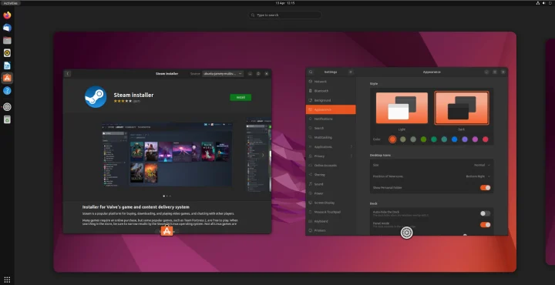**LTS (Long-Term Support) Versions:** These versions receive updates and support for five years. Examples include Ubuntu 20.04 LTS and Ubuntu 22.04 LTS.
* **Interim Releases:** These versions receive support for only nine months and are used for testing new features before they are incorporated into the next LTS version.

Ubuntu has evolved significantly over the years and is available in multiple editions, such as Ubuntu Desktop, Ubuntu Server, Ubuntu Core (for IoT devices), and specialized flavors like Kubuntu, Xubuntu, and Lubuntu.

**2. Features of Ubuntu** :-  
Ubuntu offers several features that make it a preferred choice for both personal and professional use. Some of the key features include:

* **Free and Open-Source:** Ubuntu is free to download, install, and use. Its open-source nature allows developers to modify and distribute it according to their needs.
* **User-Friendly Interface:** The GNOME desktop environment in Ubuntu provides an intuitive and visually appealing experience, making it easy for beginners to use.
* **Security and Privacy:** Ubuntu is less vulnerable to viruses and malware compared to Windows. It includes built-in security tools such as AppArmor, UFW (Uncomplicated Firewall), and automatic security updates.
* **Software Support:** Ubuntu has a vast repository of free and open-source applications. Users can install software using the APT package manager or via the Ubuntu Software Center.
* **Customization:** Users can customize the desktop environment, themes, icons, and system settings to their preference.
* **Lightweight and Performance-Oriented:** Unlike Windows, Ubuntu requires fewer system resources, making it an excellent choice for older or low-spec computers.
* **Terminal and Command-Line Interface (CLI):** Ubuntu includes a powerful terminal that allows users to execute commands, automate tasks, and manage the system efficiently.
* **Regular Updates and Community Support:** Ubuntu receives frequent updates with new features, security patches, and stability improvements. It has an active community that provides support and documentation.

**Multiple Flavors:** Ubuntu offers different versions tailored to various user preferences, including Lubuntu (lightweight), Kubuntu (KDE desktop), and Ubuntu Server (for cloud and enterprise use).  
  
**3. Difference Between Ubuntu and Windows OS** :-  
Ubuntu and Windows are two of the most popular operating systems, but they differ significantly in terms of functionality, design, and usage.

|  |  |  |
| --- | --- | --- |
| **Feature** | **Ubuntu OS** | **Windows OS** |
| **Cost** | Free and open-source | Paid, with licensing fees |
| **User Interface** | GNOME (default), can be customized | Windows GUI, limited customization |
| **Security** | More secure, less prone to viruses | Requires antivirus software |
| **Software** | Uses APT package manager and Ubuntu Software Center | Uses Microsoft Store and .exe installers |
| **File System** | Uses ext4 by default | Uses NTFS and FAT32 |
| **Customization** | Highly customizable | Limited customization options |
| **Hardware Requirements** | Runs efficiently on low-end hardware | Requires more resources |
| **Command Line** | Strong emphasis on terminal (Bash) | Command Prompt and PowerShell |
| **Gaming Support** | Limited, but improving with Steam and Proton | Extensive gaming support with DirectX |
| **Corporate Usage** | Used in servers, cloud computing, and development | Used in enterprises, businesses, and general consumers |
| **Driver Support** | May require manual driver installation | Automatically installs most drivers |
| **Updates** | Frequent security updates with no forced reboots | Mandatory updates with potential reboots |

In summary, Ubuntu is an excellent choice for developers, security-focused users, and those looking for an efficient, customizable operating system. Windows, on the other hand, is better suited for gaming, enterprise applications, and users who prefer a more familiar interface.